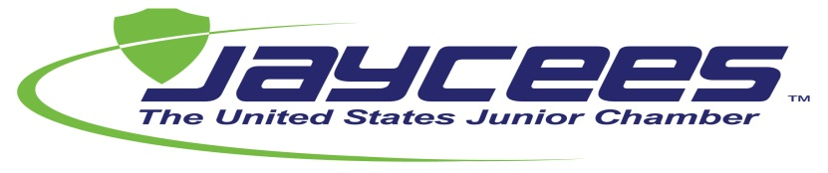
Civic Leadership Certification for States

Objective: Civic Leadership for States (CLC) provides the National Organization with an assessment of the services that each state organization provides its chapters and members. CLC is not an award program. It is a certification from National of the level of services a state organization offers its chapters and members. To be certified you simply must submit all the requirements by the final date listed, as applicable. All states achieving certification will be recognized from the podium at the Annual Meeting.

Participating in Parade is optional, not mandatory. For States interested in Parade, points will be assigned according to the deadlines outlined below.

Membership Database
Upload to the USJC web site a complete list of local Chapter Presidents including valid e-mail addresses and send State Directory to USJC Headquarters by:
January 5: 10 points
January 15: 7 points
January 31: 3 points

Plan of Action & Budget
Submit your state Plan of Action (aligned with National Plan of Action), membership growth plan and budget by:
January 31: 10 points
February 15: 7 points
February 28: 3 points

State & Local Officer Orientation
Conduct a statewide local officer training program by:
January 31: 10 points
February 15: 7 points
February 28: 3 points

Competitions & Single Project Award Entries & Judges
Submit competition & single project award entries and at least one judge for the USJC Annual Meeting: 10 points
Submit single project award entries along with at least one judge for the USJC Annual Meeting: 7 points
Submit the name of an awards judge for the USJC Annual Meeting: 3 points

Communications
Publish at least 4 issues (print or electronic) of a publication containing information on at least one National program or event in each issue and maintain a state web site: 10 points

Publish at least 2 issues (print or electronic) of a publication containing information on at least one National program or event in each issue and maintain a state web site: 7 points

Publish at least 1 issue (print or electronic) of a publication containing information on at least one National program or event and maintain a state web site: 3 points

Participation in National & International Events
Participate in at least 5 JCI or USJC events: 10 points
Participate in at least 4 JCI or USJC events: 7 points
Participate in at least 3 JCI or USJC events 3 points

Projects – Must include at least one project from every Area of Opportunity
For 10 points, upload chapter project information and photos directly to the National website:
10 projects if state organization has from 0 – 24 chapters
15 projects if state organization has from 25 - 49 chapters
20 projects if state organization has more than 50 chapters

For 7 points, upload chapter project information and photos directly to the National website:
7 projects if state organization has from 0 – 24 chapters
12 projects if state organization has from 25 - 49 chapters
15 projects if state organization has more than 50 chapters

For 5 points, upload chapter project information and photos directly to the National website:
1 projects if state organization has from 0 – 24 chapters
2 projects if state organization has from 25 - 49 chapters
3 projects if state organization has more than 50 chapters

Programs (National Priority Programs)
Conduct at least 3 programs: 10 points
Conduct at least 2 programs: 7 points
Conduct at least 1 program: 3 points

Additional Submissions
Proof of Liability Insurance: 10 points
State Equivalent of the 990 Form: 10 points
Secretary of State Proof of Good Standing: 10 points
Bylaws/Policies: 10 points
Monthly Evaluations: 10 points
Year end Evaluation: 10 points

Parade
Participating in Parade is optional. The points earned in CLC will be added to the following additional categories and points. Total points earned by States participating in Parade will be calculated, with the top 10 states being recognized.
- A/R – must be current as of 12/31 on all financial responsibilities to National – 100 points
- Membership
  - Extensions (Full 20 member extensions, not provisional) – 75 points each
  - Quarterly Retention –
60% - 74% = 25 points
75% - 100% = 50 points
  - Monthly growth – 25 points
  - Quarterly growth – 75 points
  - Member growth – 10 points for each net increase in number of members over January 1 base – (Awarded at year end)
  - New Member Orientations – 25 points for each one hosted by the State with a minimum of 5 participants
- CPG – 10 points for each new CPG submitted to National during the year
- Passport to Leadership
  - For each member reaching 10th degree – 10 points
  - For each member reaching 7th degree – 7 points
  - For each member reaching 3rd degree – 3 points
- Donations to the US JC Foundation – 25 points for each $250 donated – maximum points available is 100

